**Experiments and Results on 24 May, 2018**

**1. Removing Others [~O]:** Role Others were leading to High Accuarcy because of their abundance. These are also not relevant for our purpose. Exclude those results as well as LOC_Victim. This role is very less frequent and we will be removing it.

**2. Removing Stop Words and Punctuation[~Stop]:** Since the stop words were present in the neigbourhood of all the Roles and Entities, all the representations were having them also they are insignificant.

**3. Removing Duplicate Results [~DupRes]:** There were multiple mentions of the same entity tag pair in result.

**4. Ranging K from 1 to 15:** We tried to range K from 1 to 15 to see the variation.

**Order of application**

Old Setting -> Remove others from Results -> Remove Stop words -> Remove Duplicate Results

**Configuration E-V-C-N10 + T-V-LC :**

Entity Representation- Centroid of Nearby 10 words

Type Representation- Representation Vector

|  |  |  |  |  |  |
| --- | --- | --- | --- | --- | --- |
| **Changes** | **mAP@1** | **mAP@2** | **mAP@3** | **mAP@4** | **mAP@5** |
| Old_Results | 53.59 | 61.08 | 63.43 | 63.96 | 64.76 |
| Exclude_Others | 49.33 | 58.48 | 61.37 | 62.49 | 63.14 |
| Remove_Stopwords | 55.5 | 63.2 | 66.44 | 67.16 | 67.14 |
| Remove_Duplicate_Results | 55.5 | 64.68 | 67.82 | 68.48 | 68.91 |

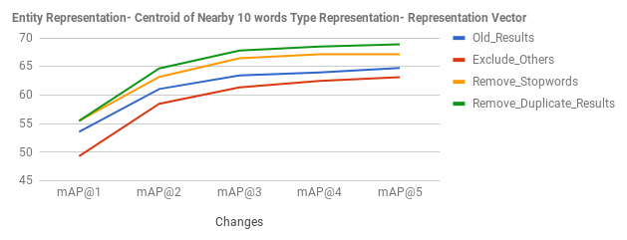

**Configuration E-W-N10 + T-V-SW30 :**

Entity Representation- Nearby left 10, right 10 words

Type Representation- 30 Similar words to Type Representation Vector

|  |  |  |  |  |  |
| --- | --- | --- | --- | --- | --- |
| **Changes** | **mAP@1** | **mAP@2** | **mAP@3** | **mAP@4** | **mAP@5** |
| Old_Results | 47.33 | 53.99 | 57.46 | 59.76 | 60.77 |
| Exclude_Others | 42.78 | 50.81 | 54.55 | 56.59 | 57.62 |
| Remove_Stopwords | 43.67 | 54.67 | 57 | 58.36 | 58.97 |
| Remove_Duplicate_Results | 43.67 | 55.47 | 59.03 | 60.26 | 60.81 |

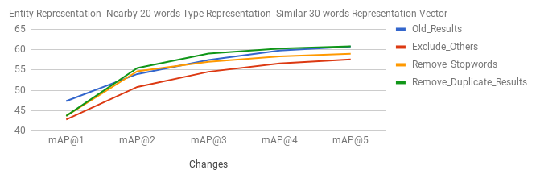

4. As we increase K from 1 – 15 the performance becomes saturated and starts to go down.

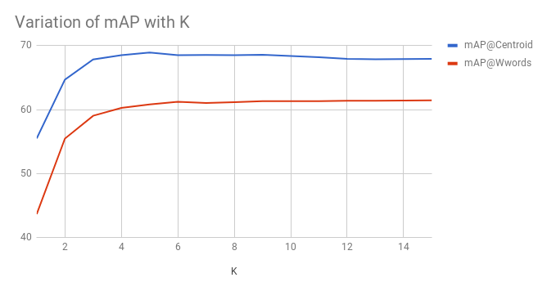

**Summary:**

1. Excluding xxx_Others and LOC_Event reduced the performace score by **~3-4%**

2. Removing stop words have given better representative words incresing the overall performance in all configurations. by **~4-5%** in centroid representation and **~2-3%** in word representation.

3. Removing duplicate results have also improved the performance, adding more relevant results. Though the permonace is not increased much becuase **24%** entities have multiple mentions in our corpus.

**New Representative words for Role after removing stop words**

There were so many stop words in the representative words of role. After Removing Stop words, we were able to get few good words.

**LOC_Event:**

'298.8', 'friday', 'one', 'bomb', 'near', 'blast','monday','two', 'waste-papers','wednesday', 'riyas', 'people', 'brought','area','killed','blasts', 'attack','another', 'first','said', 'asimanand', 'time', 'outside','explosion', 'day','just','khallikote','since', 'ttp-pakistan', 'went'

**LOC_Accused**

'asimanand', 'shabari', 'convenership', 'riyas', '9497990026', 'kunangudi', 'l-18','0475-2222595', bomb, 'koukuntla','immadoddin', 'charge-sheet', 'one', 'kalasangra', 'harekrushna', 'saif-ur-rehman', 'muzafarpur', 'sudershan', 'arrested', 'viqar', 'accused', 'brought', 'khayum', 'abubucker', 'charge-sheets', 'gupta', ‘shekowal', 'charge', 'sharp-shooter', 'two'

**PER_Accused**

'accused', 'convenership', 'arrested', 'case', 'shabari', charge-sheet', 'sudershan', 'charge', 'l-18', 'charge-sheets', '0475-2222595', 'one', 'brought', 'mr.', 'others', 'harekrushna', 'abinav', 'bomb', 'court', '9497990026', 'time', 'two', 'though', 'said', 'monday', 'police', 'several', 'friday', earlier', 'markandey'

**PER_Victim**

'one', 'injured', 'near', 'said', 'killed', 0.8741815090179443, 'mr.', another', 'maudany', 'blast', 'bahadurganj', 'later', 'others', 'sudershan', 'asimanand', 'people', riyas', 'went', 'abubucker', 'several', 'muzafarpur', 'friday', 'monday', 'dead', 'attack', 'however', 'convenership', 'time', 'told', 'home', 'minister'

**ORG_Victim**

'attack', 'bomb', 'ttp-pakistan', 'monday', 'attacks', 'two', 'one', 'sudershan', 'area', 'khyber-pukhtoonkhwa', 'hinduthat', 'riyas', 'said', explosives-laden', 'friday', 'harekrushna', 'near', 'security', 'killed', 'blast', 'wednesday', 'parirakshana', 'another', 'asimanand', 'convenership', 'shabari', '298.8', 'kalasangra', 'several', 'ethiopian-themed'

**ORG_Accused**

'attacks', 'convenership', 'asimanand', 'shabari', 'two', 'riyas', 'one', 'ttp-pakistan', 'sudershan', 'claimed', 'accused', 'involved', 'earlier', 'attack', 'abubucker', 'said', 'bomb', 'government', 'jehadi/terrorist', 'time', 'blast', 'involvement', 'even', '298.8', 'several', 'ethiopian-themed', 806-page, 'khyber-pukhtoonkhwa', 'group', 'though'